SEA-ME
Be Visible
in Marine Environments

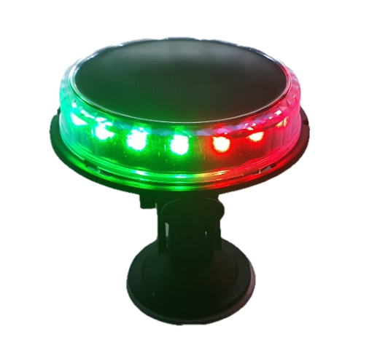

Solar/USB charged
Wireless Navigation Light

Inhoudsopgave
Section I - Purpose 2
Section II - Description 3
2.1 Introduction 3
2.2 Product Structure 4
2.3 Technical Parameters 5
2.4 Functions 6
Section III - Installation Instructions 7
3.1 Compatibility 7
3.2 Installation Guidelines 7
3.2.1 General Positioning 7
3.2.2 Mounting Procedure 7
3.3 Environmental Considerations 7
Section IV - Operation & Usage Instructions 8
4.1 Operation Instructions 8
4.1.1 Powering On 8
4.1.2 Selecting Light Functions 8
4.1.3 Automatic Light Sensor Operation 8
4.1.4 Solar Charging 8
4.1.5 USB Charging 8
4.1.6 Remote Control Operation 9
4.1.7 Remote Pairing 9
4.2 Usage Instructions 9
4.2.1 Position Indication 9
4.2.2 Emergency Signaling 9
4.2.3 Anchor and Auxiliary Lighting 9
4.2.4 Usage Limitations 9
Section V - Service Life & Safety 10
5.1 Product Warranty 10
5.2 Safety Precautions 10
Section VI - Inspection 11
6.1 Routine Inspection 11
6.2 Performance Check 11
6.3 Remote Control Troubleshooting 11
Section VII - Maintenance 12
7.1 Storage Conditions 12
7.2 Battery Maintenance 12
7.3 Solar Charging Guidelines 12
7.4 Performance Notes 12
Section VIII - Repair & Disposal Instructions 13
8.1 Repair Instructions 13
8.2 Disposal Instructions 13

Section I - Purpose

These instructions provide guidance on the proper operation and maintenance of the Solar/USB Navigation Light.

Section II - Description

2.1 Introduction

The Solar/USB Navigation Light is a solar- and USB powered signaling device equipped with a built-in 3.7V, 2.6Ah rechargeable lithium battery (approximately 10Wh). It is designed primarily for small leisure vessels but can also be installed on other objects that require position indication or visibility marking.

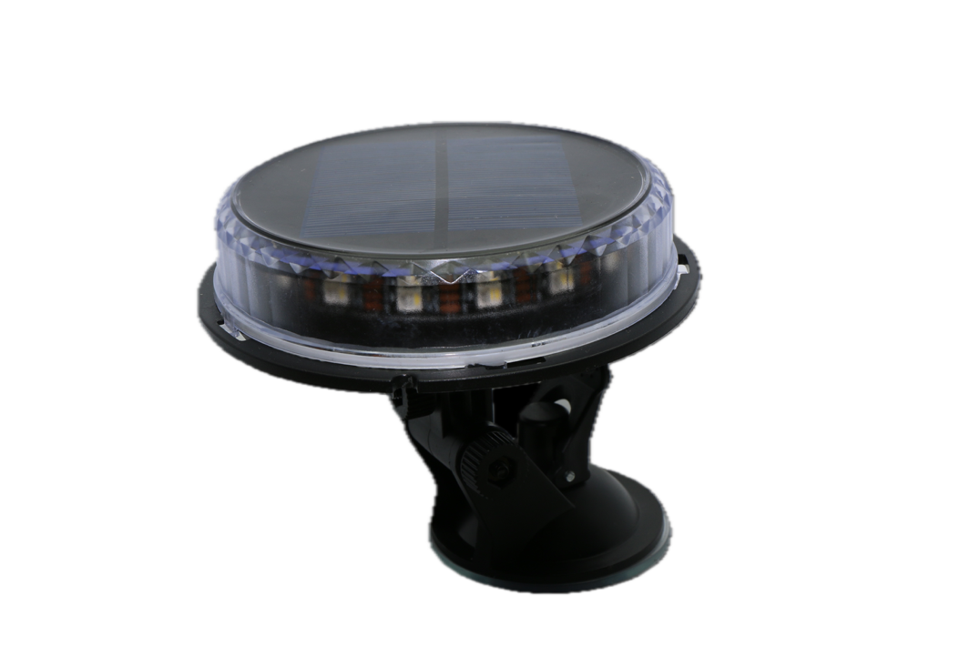
Figure 1 Solar/USB Navigation Light

The light is wireless, IP66 waterproof, and features three control methods:

- Manual Power Switch:
A main power button allows users to completely switch the light on or off.
- Light Sensor Switch: An internal light sensor automatically activates the last selected lighting mode at night and turns the light off during daylight, based on ambient light conditions.
When turned off due to strong sunlight, the light automatically checks the surrounding brightness every 60 seconds. If the ambient light intensity drops below a preset threshold, the light turns on again automatically.
- Wireless Remote Control:
The included remote control enables users to change light functions conveniently from a distance. Refer to sections 4.1.6 and 4.1.7 for details.

The Solar/USB Navigation Light provides versatile functionality through the remote control. Users can easily switch between multiple modes such as steady light, flashing light, SOS signal, and red/green color options. The last selected function is stored in memory and will automatically reactivate when ambient light conditions trigger the light sensor.

Because the device supports both solar and USB charging, it performs reliably in a wide range of environments. In regions with abundant sunlight, the solar panel ensures efficient charging, while in low-sunlight conditions, the USB-C charging port offers a convenient alternative. The light can also operate when connected to a USB power bank, which simultaneously charges the internal battery.

2.2 Product Structure

The Solar/USB Navigation Light consists of the following components: a solar panel, USB-C charging port (for power input only), LED module with lens, built-in 3.7V lithium battery, and an internal control circuit board.

⚠️ Do not attempt to disassemble the light. Refer to section V.

Each unit includes a pre-programmed wireless remote control and a versatile positioning bracket with a ¼–20 thread. Optional accessories include a 15 cm extension rod and additional wireless remotes.
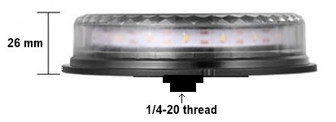
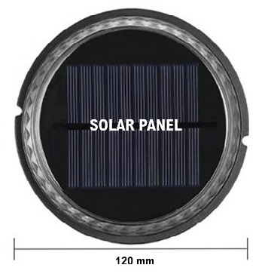

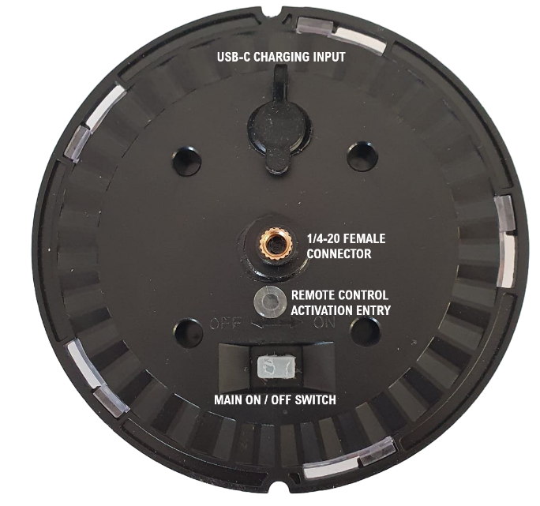

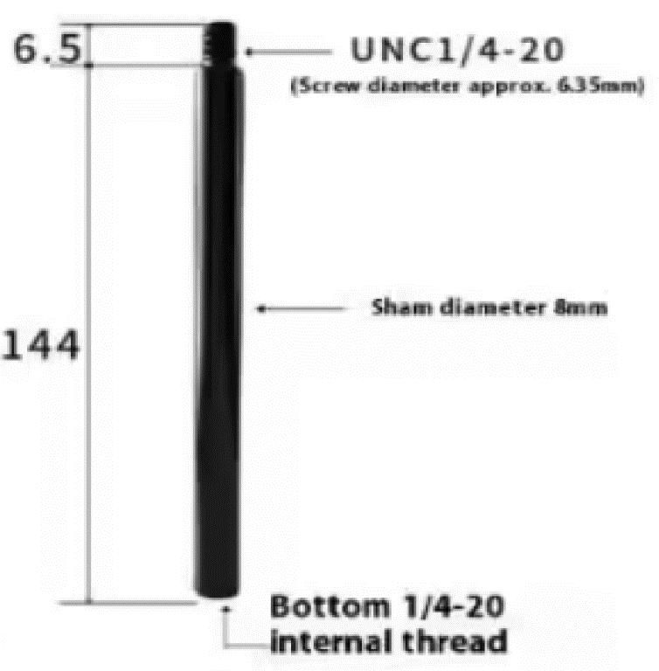

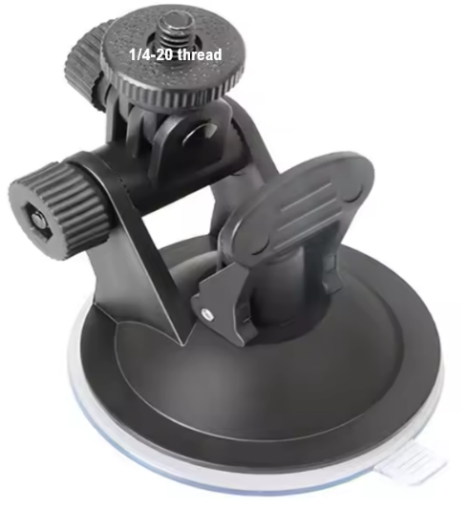
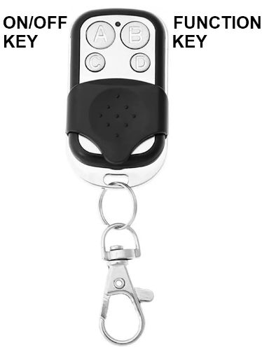

Positioning Bracket, Wireless Remote, Extension Rod (optional)
with suction cup extra remotes optional

2.3 Technical Parameters

Parameter | Specification
Light Source | High-intensity LEDs
Primary Activation | Automatic via light sensor
Function Switching | Wireless remote control
Remote Control Range | Over 20 meters (unobstructed)
Battery Type | Built-in rechargeable lithium battery, 3.7V / 2.6Ah (approx. 10Wh)
Charging Methods | - Solar power: Approximately 16 hours of strong sunlight (≈2 clear days) for a full recharge of a depleted battery.  - USB-C power: Approximately 8 hours for full recharge.
Power Input Port | USB-C (charging only)
Maximum Wind Resistance | Beaufort Force 12
Operating & Storage Temperature | -30°C to +65°C (-22°F to +149°F)
Dimensions | Main Body: 120 × 26 mm
Weight | Light and Remote: 225 g  Bracket and Screws: 120 g
Waterproof Rating | IP66 (remote control not waterproof)
Material Properties | UV-resistant, fire-resistant, oil-resistant, mold-proof, corrosion-proof, waterproof
Certifications | CE and FCC compliant
Warranty | 1 year from date of purchase

2.4 Functions

The Solar/USB Navigation Light provides multiple lighting modes suitable for various marine and signaling applications. The functions can be controlled via the wireless remote or the automatic light sensor. The last selected mode is saved in memory and will automatically reactivate when the light sensor detects low ambient light.

Visibility and Performance

Mode/Color | Visibility Range
Green, Red, Bi-Color, Tri-Color | > 1 nautical mile
White (Steady, SOS, Flashing) | > 2 nautical miles

Working Time (Fully Charged Battery)
Flashing Light | > 20 hours
SOS Light | > 20 hours
Steady Light | > 12 hours

Sequence | Function | Description / Typical Use
1 | Green Steady Light | Starboard navigation light
2 | Red Steady Light | Port navigation light
3 | Red & Green Steady Light | Bi-color navigation light
4 | White Stern Steady Light | Stern visibility light
5 | White Steam Steady Light | Forward-facing navigation light
6 | Red, Green & White Steady Light | Tri-color navigation light
7 | White 360° Steady Light | Anchor or all-round light
8 | White 360° SOS Light | Distress or emergency signal
9 | White 360° Flashing Light | Position or attention light

Notes:
- The visibility range and working time are based on a fully charged battery under standard test conditions.
- Continuous operation of steady light modes for extended periods may reduce overall battery lifespan.
- The light automatically resumes the last active mode when ambient light falls below the preset brightness threshold.

Section III - Installation Instructions

3.1 Compatibility

The Solar/USB Navigation Light is suitable for installation on a wide range of objects requiring position indication or visibility marking, such as:
- Yachts, fishing boats, and leisure craft
- Docks and marinas
- Buoys, markers, or floating equipment
- Gardens, walkways, and building exteriors

For optimal performance, install the light in a location with unobstructed sunlight exposure or ensure access to a USB power source when solar charging is limited.

3.2 Installation Guidelines

3.2.1 General Positioning

Install the Solar/USB Navigation Light on the topmost point of a vessel, structure, or mounting surface to ensure maximum visibility from all directions.

3.2.2 Mounting Procedure

- Ensure the mounting surface is clean, dry, and flat.
- Attach the light to the positioning bracket using the threaded connector (¼–20 thread).
- Set the lever on the positioning bracket to the upward position.
- Place the bracket on the desired surface and push the lever down to create a vacuum seal with the suction cup.
- Adjust the bracket to achieve the desired angle and direction for optimal visibility.

⚠️ Caution:
- Ensure the suction cup is securely attached before use.
- Do not install the light near moving parts, exhaust outlets, or heat sources.
- In high-vibration or long-term installations, consider additional mechanical fastening to prevent detachment.

3.3 Environmental Considerations

- Position the light where it receives direct sunlight for most of the day to maintain full charging efficiency.
- Avoid installing under shaded areas, awnings, or metal structures that may block sunlight.
- If used in saltwater environments, periodically rinse the bracket and suction cup with fresh water to prevent salt buildup and maintain adhesion strength.

Section IV - Operation & Usage Instructions

4.1 Operation Instructions

4.1.1 Powering On
After installation, switch the main POWER button on the light to the “ON” position.
Pressing the “ON/OFF” button (A) on the wireless remote control to activate and deactivate the device while in operation.

4.1.2 Selecting Light Functions
Press the “FUNCTION SWITCH” button (B) on the remote control to cycle through the available lighting modes. Refer to Section 2.4 for the complete sequence and description of each function.

4.1.3 Automatic Light Sensor Operation
When the device is turned on, the light sensor is always active. The light will automatically turn on at night and switches off during the day based on ambient brightness.
When the light is turned off due to strong sunlight, it performs an ambient light check every ~ 60 seconds.
If the light intensity drops below the preset threshold, the light automatically turns on again using the last selected mode.

4.1.4 Solar Charging
When exposed to sunlight, the built-in solar panel charges the internal battery whether the light is switched on or off.
- A full solar charge typically requires about 16 hours of strong sunlight (≈ two clear days).
- Working time varies by mode:
  - Flashing / SOS light: > 20 hours
  - Steady light: > 12 hours
💡 Tip:
To prevent power depletion, avoid using steady light continuously for more than 12 hours without adequate charging intervals.

4.1.5 USB Charging
The light can also be charged via the USB-C port located at the bottom of the housing.
- A fully depleted battery will recharge in approximately 8 hours via USB.
- The light can operate while charging from a USB power bank or power supply.

4.1.6 Remote Control Operation
- The wireless remote operates at a distance of over 20 meters (without obstruction).
- If the LED indicator on the remote becomes weak, replace the battery.
- The remote control is not waterproof—keep it dry and avoid exposure to moisture.

4.1.7 Remote Pairing
Each remote is pre-paired with the corresponding light.
If the original remote is lost or replaced, follow these steps to pair a new remote:
- Remove the small plug labeled “REMOTE CONTROL ACTIVATION ENTRY” at the bottom of the light.
- Press the internal button using a small screwdriver.
- Press the “A” button on the new remote control to complete pairing.
- Reinsert the plug firmly to maintain waterproof integrity.
Multiple remotes can be paired with the same light to enable synchronized control.

4.2 Usage Instructions

4.2.1 Position Indication
Use the flashing mode to indicate the vessel’s position or to enhance visibility in low-light conditions.

4.2.2 Emergency Signaling
Activate the SOS mode in emergency or distress situations to broadcast a visual alert visible from over two nautical miles.

4.2.3 Anchor and Auxiliary Lighting
The white steady light can serve as an anchor light or general-purpose illumination in leisure or docking scenarios.

4.2.4 Usage Limitations
⚠️ Important Notice:
This product is not a certified navigation light and must not be used as a replacement for standard, regulation-compliant marine navigation lights.
It is suitable for leisure use and for vessels under 20 meters in length, or as a supplementary lighting device.

Section V - Service Life & Safety

5.1 Product Warranty
The Solar/USB Navigation Light is covered by a one-year limited warranty from the date of purchase.
The warranty applies to defects in materials or workmanship under normal operating conditions and proper use.
The warranty does not cover:
- Damage caused by misuse, neglect, impact, or unauthorized modification
- Water damage resulting from improper sealing or removal of protective components
- Normal wear and tear or battery degradation over time
For warranty claims or technical assistance, contact your authorized dealer or distributor with proof of purchase.

5.2 Safety Precautions
The Solar/USB Navigation Light contains a rechargeable lithium battery and electronic components that require careful handling.
Please observe the following safety instructions:
- Do not disassemble or modify the product or battery.
- Do not incinerate or expose the light to open flames or excessive heat.
- Avoid short-circuiting the battery terminals or USB-C connector.
- Store and operate the device within the temperature range of -30°C to +65°C (-22°F to +149°F).
- Do not immerse the wireless remote in water—it is not waterproof.
- Keep the product away from children unless supervised by an adult.
- Avoid direct eye exposure to the LED light when operating at close range.
- Dispose of the product and battery in accordance with local environmental regulations (see section 8.2).
⚠️ Warning:
Mishandling lithium batteries may cause overheating, leakage, fire, or explosion.
Always follow these safety instructions to prevent injury or equipment damage.

Section VI - Inspection

6.1 Routine Inspection
To ensure optimal performance and a long service life, inspect the Solar/USB Navigation Light regularly.
Perform the following checks every 3–6 months, depending on environmental conditions and frequency of use:
- Clean the solar panel, light sensor, and lens with a soft cloth to remove dust, salt, or debris.
This improves sunlight absorption and ensures accurate light sensing.
- Check the bracket and suction cup for secure attachment and signs of wear.
- Verify remote functionality by testing all light modes and control distance.
- Inspect for visible damage to the housing, solar panel, or charging port.
💡 Tip:
Regular cleaning and inspection significantly enhance solar charging efficiency and overall reliability.

6.2 Performance Check
If the light fails to operate correctly:
- Set the main POWER switch to the off position to switch the light off.
- To ensure complete recharging, either:
  - Expose the device to direct sunlight for at least 2 full days
  - Connect the device it via the USB-C port to a power source for at least 8 hours
- Turn the light back on and test functionality using the remote control.
If the problem persists, verify that the USB-C port, cable and remote control are functioning correctly before contacting service support.

6.3 Remote Control Troubleshooting
If the wireless remote does not respond:
- Replace the remote battery and retry.
- Re-pair the remote with the light following the procedure in Section 4.1.7.
- Ensure there are no obstacles or metallic surfaces between the remote and the light during operation.
⚠️ Note:
The remote control is not waterproof. Exposure to moisture may cause malfunction. If the remote becomes wet, dry it thoroughly before use.

Section VII - Maintenance

The Solar/USB Navigation Light is designed to be virtually maintenance-free. However, basic care and periodic checks are recommended to maintain optimal performance and extend the product’s service life.

7.1 Storage Conditions
- Store the device in a cool, dry place away from direct sunlight when not in use.
- Keep the original packaging intact to protect the light during storage or transportation.
- Avoid placing heavy objects on top of the packaged product.

7.2 Battery Maintenance
- Recharge the light to 50% at least once every 3 months during periods of storage or inactivity to maintain battery health.
- If the light is stored for longer than 3 months, place it in direct sunlight for at least 8 hours before use to ensure battery capacity.
- Avoid long-term storage with a completely discharged battery, as this may shorten the battery’s lifespan.

7.3 Solar Charging Guidelines
- The solar charging efficiency depends on weather, sunlight angle, and environmental conditions.
- For best performance, position the light so that the solar panel faces direct sunlight for most of the day.
- Continuous operation of the steady light mode should not exceed 12 hours per day to prevent over-discharge of the battery.

7.4 Performance Notes
- The stated working hours are based on a fully charged battery and typical environmental conditions during the first year of use.
- Over time, battery capacity and runtime may gradually decrease — this is a normal characteristic of lithium batteries.

Section VIII - Repair & Disposal Instructions

8.1 Repair Instructions
The Solar/USB Navigation Light is not designed to be disassembled or repaired by the user.
- If the light fails to function properly within the one-year warranty period, contact your authorized dealer or manufacturer for assistance.
- The warranty covers defects in materials or workmanship under normal use.
- For products that fail after the warranty period, users should purchase a replacement unit rather than attempting repairs.
⚠️ Warning:
Attempting to open or modify the light or its battery may cause irreversible damage, electrical shock, or fire hazard.

8.2 Disposal Instructions
To protect the environment and comply with local regulations:
- Do not dispose of the light or its lithium battery in household waste.
- Take used, defective, or expired products to an approved recycling or electronic waste facility.
- Follow all local environmental and safety regulations regarding lithium batteries and electronic components.

